

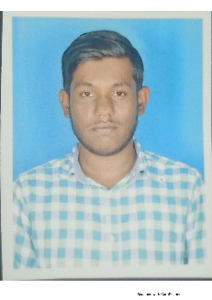

Personal Details…

**Bhavan R S**

**Curriculum Vitae**

|  |  |
| --- | --- |
| Name | Bhavan R S |
| Designation | Analyst-A4/Software Engineer |
| Birth Date | 22-03-1998 |
| Residence | Rayalpad, Kolar, India |
| Nationality | Indian |
| Martial Status | Unmarried |
| Gender | Male |

Profile…

Competencies…

Languages…

Experience…

I am an A4 Analyst who has successfully completed Learning and Development Training of JEE with Angular. I would be glad to obtain a responsible position in the organization and serve it with my determination and honesty and to enhance my skills to achieve the goals of the company.

Web Tools Spring Boot, Angular 10, HTML, CSS

Languages Core Java, Basics of JavaScript, TypeScript

Database PostgreSQL

Third party Tools Postman, Swagger Operating Systems Windows

|  |  |  |  |
| --- | --- | --- | --- |
| Languages | Speak | Read | Write |
| English | Yes | Yes | Yes |
| Kannada | Yes | Yes | Yes |
| Telugu | Yes | No | No |
| Hindi | No | Yes | Yes |

|  |  |  |
| --- | --- | --- |
| Project name | Employee Management System | |
| Client | Learning and Development Training Project | |
| Technology Used | Core Java | Postman |
| Spring Boot | Angular 8 |
| Postgres SQL |  |



Bhavan R S

**Curriculum Vitae**

Training…

Training Attended

* L&D training of JEE with Angular by Capgemini Technologies (17 Mar 2022 – 13 June 2022)

Education …

* (2015-2019) B.E, CMR Institute of Technology, CGPA – 7.4
* (2013-2015) PUC, Venkatadri Independent PU College, Percentage - 80℅.
* (2013) SSC, V S R School, Percentage - 79%

Contact Details…

|  |  |
| --- | --- |
| Permanent Address | Rayalpad (P), Srinivaspur (T), Kolar-563134 |
| Mobile | 8296627577 |
| Corporate Email | [bhavan.r-s@capgemini.com](mailto:bhavan.r-s@capgemini.com) |
| Personal Email | [bhavanreddy1988@gmail.com](mailto:bhavanreddy1988@gmail.com) |